QUESTIONS FOR ADDITIONAL STUDY

1. Tell your story. Describe a time in your life when you became very
focused on accomplishing a task. How did you avoid distractions?

2. What are some of the things in our culture today that prevent us
from being focused on our mission?

3. Read the following passages and note the Bible says about our
being focused on our mission:

a) Joshua 1:9
b) Proverbs 3:5-6
c) Proverbs 4:25-27
d) Isaiah 26:3
e) Matthew 6:24
f) Ephesians 5:15-16
g) Philippians 3:12-14

4. What did Jesus mean when He spoke of Jerusalem’s house being
left “desolate?”

5. What practical application are you going to make from this week’s
message? (Share your decision with another person.)
- I am going to prayerfully consider my short-term and long-term goals in life and write them down.
- I am going to do a Bible study on the word “compassion.”
- I am going to memorize Joshua 1:9.
Cornerstone Church April 28, 2024
Luke 13:31-35 Study Series #063

Keeping the Focus on Our Mission

I. Introduction

II. Overcoming Our Fear

A. The Pharisee’s Warning

(See Luke 13:31; Matthew 19:1; Mark 10:1; John 10:40-42)

B. Herod’s Threat

(See Luke 13:31; Luke 3:1; Mark 6:17-18; Luke 3:20;
Mark 6:19; Mark 14:7; Mark 6:14-16; Luke 23:8;
Matthew 14:1-2; Luke 9:9)

C. Jesus’ Response

(See Luke 13:32-33; Matthew 23:13-29; Matthew 16:6;
Song of Solomon 2:15; Lamentations 5:18; Exodus 19:10-11;
Luke 13:33; II Kings 21:16; Hebrews 11:37;
II Chronicles 24:20-22; Genesis 26:24; Haggai 2:5;
II Timothy 1:7; Psalm 56:11; Acts 4:29-31)

III. Maintaining Our Compassion

A. The Lament of Jesus

(See Luke 13:34; Matthew 5:13-14; Ezekiel 33:11;
Ezekiel 18:23; Leviticus 24:14-16; Leviticus 20:1-3;
Acts 6:11; Acts 7:58-60)

B. The Destiny of Jerusalem

(See Luke 13:35; John 1:11; John 3:19; Acts 3:14;
Matthew 24:2; Mark 13:2; Ephesians 2:12)

C. The Hope for the Future

(See Luke 13:35; Psalm 118:26; Luke 2:30;
II Corinthians 5:16; Zechariah 12:10)

IV. Conclusion

If you would like to know more about what it means to be a Christian, or if you would like to talk with someone or have someone pray for you, please see the pastor after the service and he or one of our church leaders will be glad to speak with you.
Passage of Study
Luke 13:31-35

³¹ Just at that time some Pharisees approached, saying to Him, “Go away, leave here, for Herod wants to kill You.” ³² And He said to them, “Go and tell that fox, ‘Behold, I cast out demons and perform cures today and tomorrow, and the third day I reach My goal.’ ³³ Nevertheless I must journey on today and tomorrow and the next day; for it cannot be that a prophet would perish outside of Jerusalem. ³⁴ O Jerusalem, Jerusalem, the city that kills the prophets and stones those sent to her! How often I wanted to gather your children together, just as a hen gathers her brood under her wings, and you would not have it! ³⁵ Behold, your house is left to you desolate; and I say to you, you will not see Me until the time comes when you say, ‘Blessed is He who comes in the name of the Lord!’

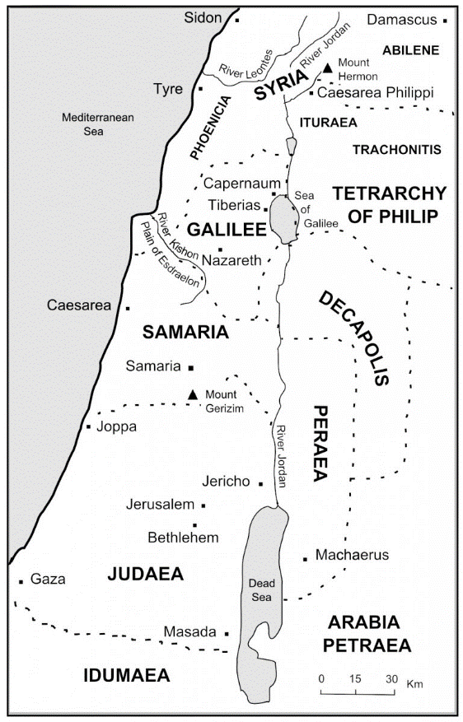

All quotations taken from the New American Standard unless otherwise noted. NASB. Nashville, TN: Thomas Nelson Publishers 1995. A free PDF of this note sheet is available: www.cssbchurch.org/sermons-2. © 2023.

