QUESTIONS FOR ADDITIONAL STUDY

1. Tell your story. Describe a time when the Word of God encouraged
you to trust God for the future.

2. How has the war in Israel affected your view of world events?

3. Read the following passages and note the Bible says about
prophecy:

a) Amos 3:7
b) I Corinthians 13:2
c) I Corinthians 14:3
d) II Peter 1:19
e) II Peter 1:21-22
g) Revelation 1:3
g) Revelation 19:10

4. How is the Tribulation going to affect the view of the Jews
concerning Jesus Christ?

5. What practical application are you going to make from this week’s
message? (Share your decision with another person.)
- I am going to pray for the people of Israel and the peace of Jerusalem each day. (Psalm 122:6)
- I am going to read a book on Bible prophecy.
- I am going to memorize II Peter 1:21-22
Cornerstone Church November 12, 2023
Various Scripture Verses

What About Israel?
Part Three – The Future of Israel

I. Introduction

A. Israel: Past, Present, and Future

(Genesis 12:1-3; Deuteronomy 9:6; Deuteronomy 7:7-8;
Genesis 12:7; Exodus 23:31; Ezekiel 26:1-7; Zephaniah 3:9;
Ezekiel 34:36; Isaiah 27:6; Acts 17:11)

B. A Warning about Replacement Theology

(See Acts 3:12; Acts 4:8,10; Acts 21:19; I Corinthians 10:32)

C. Why is Israel so Significant?

(See Zechariah 12:2-3; I Kings 11:36; cf. II Kings 21:7;
II Chronicles 33:7; Genesis 17:1)

II. What About Israel? – The Future of Israel

A. The Gathering of Israel

(See Ezekiel 20:33-38; Ezekiel 22:17-22; Zephaniah 1:7-18;
Zephaniah 2:1-2)

B. The Rapture of the Church

(See I Thessalonians 4:17; I Thessalonians 4:13-18;
Matthew 24:36-44; Mark 13:32-37; Matthew 24:45-51;
Luke 12:42-48; I John 3:2-3)
C. The Appearance of the Antichrist

(See II Thessalonians 2:1-3; II Thessalonians 2:6-7)

D. The Tribulation

(See Daniel 9:24-27; Isaiah 28:14-22)

E. The Abomination of Desolation

(See Daniel 9:27; Matthew 24:15-16; II Thessalonians 2:3-4;
Revelation 11:1-2; Revelation 13:18)

F. The Nations Attack Israel

(See Ezekiel 38; Ezekiel 39)

G. The Invading Nations Destroyed

(See Ezekiel 39:2-4)

III. Conclusion

If you would like to know more about what it means to be a Christian, or if you would like to talk with someone or have someone pray for you, please see the pastor after the service and he or one of our church leaders will be glad to speak with you.
Key Passage of Study
Zechariah 12:2-3

“Behold, I am going to make Jerusalem a cup that causes staggering to all the peoples around; and when the siege is against Jerusalem; it will also be against Judah. And in that day will I make Jerusalem a burdensome stone for all people…”

The Four Quarters of Jerusalem

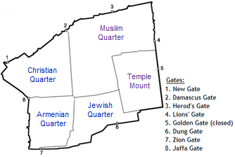

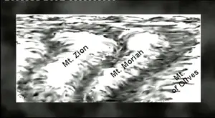

All quotations taken from the New American Standard unless otherwise noted. NASB. Nashville, TN: Thomas Nelson Publishers 1995. A free PDF of this note sheet is available: www.cssbchurch.org/sermons-2. © 2023.

