QUESTIONS FOR ADDITIONAL STUDY

1. Tell your story. Describe a woman in your life who had an impact
on your spiritual life? How did she influence your spiritual walk?

2. How have the roles of women changed over the years in our culture?

3. Read the following passages and note what the Bible says about
women:

a) Genesis 2:18
b) Proverbs 14:1
c) Proverbs 31:26
d) Proverbs 31:30
e) I Timothy 2:9-10
f) Titus 2:3-5
g) I Peter 3:3-4

4. Why did Jesus want the support of those around Him in ministry?

5. What practical application are you going to make from this week’s
message? (Share your decision with another person.)
- I am going to thank a woman in my life who has been instrumental in my spiritual growth.
- I am going to begin supporting a ministry on a regular basis.
- I am going to memorize Proverbs 31:30.
Cornerstone Church July 16, 2023
Luke 8:1-3 Study Series #033

The Traveling Companions of Jesus

I. Introduction

A. Answered Prayer

B. Women in Ancient Cultures

(See John 4:1-38)

C. Jesus and Women

(See Isaiah 53:2; Luke 4:38-39; Luke 7:11-17; Luke 7:36-50;
Luke 8:1-3; Luke 8:43-48; Luke 10:38-42; Luke 13:10-17;
Luke 22:27-31; Acts 1:14)

II. The Traveling Companions of Jesus

A. The Twelve

(See Luke 8:1; Luke 7:1-10; Luke 7:11-17; Luke 4:43;
Luke 7:22; Luke 8:1; Luke 6:12-16; Mt 10:1; Mark 6:7;
Luke 9:1)

B. Mary Magdalene

(See Luke 8:2; Matthew 1:18; John 11:19; John 19:25;
Acts 12:12; Romans 16:6; Luke 7:35-50; Matthew 27:56;
Mark 15:47; John 20:1-18)

C. Joanna

(See Luke 8:3; Luke 23:55; Luke 24:10)

D. Susanna

(See Luke 8:3; Hebrews 10:32-35)

E. Many Others

(See Luke 8:3; Psalm 50:10-12; Luke 4:3-4; Acts 17:24-25;
Matthew 14:13-21; Matthew 6:3-4; Philippians 4:17;
II Corinthians 9:7; Hebrews 11:24-26)

III. Conclusion

If you would like to know more about what it means to be a Christian, or if you would like to talk with someone or have someone pray for you, please see the pastor after the service and he or one of our church leaders will be glad to speak with you.
Passage of Study
Luke 8:1-3

¹ Soon afterwards, He began going around from one city and village to another, proclaiming and preaching the kingdom of God. The twelve were with Him, ² and also some women who had been healed of evil spirits and sicknesses: Mary who was called Magdalene, from whom seven demons had gone out, ³ and Joanna the wife of Chuza, Herod’s steward, and Susanna, and many others who were contributing to their support out of their private means.

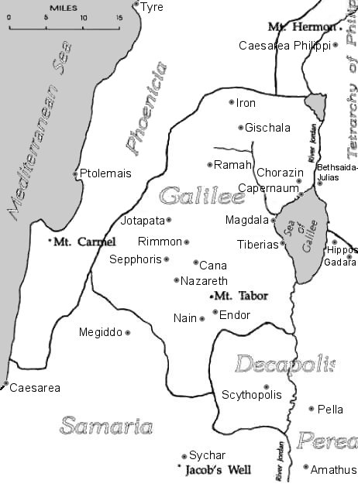

All quotations taken from the New American Standard unless otherwise noted. NASB. Nashville, TN: Thomas Nelson Publishers 1995. A free PDF of this note sheet is available: www.cssbchurch.org/sermons-2. © 2023.

