QUESTIONS FOR ADDITIONAL STUDY

1. Tell your story. Describe a time when you felt a sense of
compassion toward someone who was going through a difficult
time. What did you do to help them?

2. How would you define compassion? How is it different from
sympathy?

3. Read the following passages and note what the Bible says about
grief:

a) Joshua 1:9
b) Psalm 34:18
c) Psalm 147:3
d) Isaiah 26:3
e) Matthew 5:4
f) II Corinthians 1:3-4
g) Revelation 21:4

4. Why were the people fearful when the widow’s son was raised from
the dead?

5. What practical application are you going to make from this week’s
message? (Share your decision with another person.)
- I am going to do something thoughtful as a practical demonstration of my compassion for someone who is going through a difficult time.
- I am going to pray for someone who is grieving a loss.
- I am going to memorize Isaiah 26:3.
Cornerstone Church June 25, 2023
Luke 7:11-17 Study Series #030

Jesus Raises the Widow’s Son

I. Introduction

A. The Unusual Graveside Service

B. Raising the Dead

(See I Kings 17:17-24; II Kings 4:18-37; II Kings 13:20-21;
Matthew 9:18-26; Mark 5:21-43; Luke 8:40-56; John11:1-44;
Luke 7:11-17; Acts 9:36-43; Acts 20:7-12; Luke 7:22;
Matthew 27:50-53; Luke 7:16)

II. Jesus Raises the Widow’s Son

A. Divine Direction

(See Luke 7:11; I Samuel 28:7-25; II Kings 4:18-37)

B. Divine Appointment

(See Luke 7:12; Deuteronomy 21:23; Acts 5:5-10;
Jeremiah 6:26; Amos 8:10; Zechariah 12:10)

C. Divine Compassion

(See Luke 7:13; Matthew 9:36; Matthew 14:14; Mark 6:34;
Mark 1:40-41; Hebrews 4:15-16)

D. Divine Power

(See Luke 7:14; Matthew 9:18; John 11:3; Numbers 19:11-22;
Luke 7:15; I Kings 17:23; Mark 5:41; John 11:43)

E. Earthly Response

(See Luke 7:16-17; Deuteronomy 18:15; John 1:21;
Acts 3:22-23; Luke 8:4; Luke 8:19; Luke 8:42)

III. Conclusion

If you would like to know more about what it means to be a Christian, or if you would like to talk with someone or have someone pray for you, please see the pastor after the service and he or one of our church leaders will be glad to speak with you.
Passage of Study
Luke 7:11-17

¹¹ Soon afterwards He went to a city called Nain; and His disciples were going along with Him, accompanied by a large crowd. ¹² Now as He approached the gate of the city, a dead man was being carried out, the only son of his mother, and she was a widow; and a sizeable crowd from the city was with her. ¹³ When the Lord saw her, He felt compassion for her, and said to her, “Do not weep.” ¹⁴ And He came up and touched the coffin; and the bearers came to a halt. And He said, “Young man, I say to you, arise!” ¹⁵ The dead man sat up and began to speak. And Jesus gave him back to his mother. ¹⁶ Fear gripped them all, and they began glorifying God, saying, “A great prophet has arisen among us!” and, “God has visited His people!” ¹⁷ This report concerning Him went out all over Judea and in all the surrounding district.

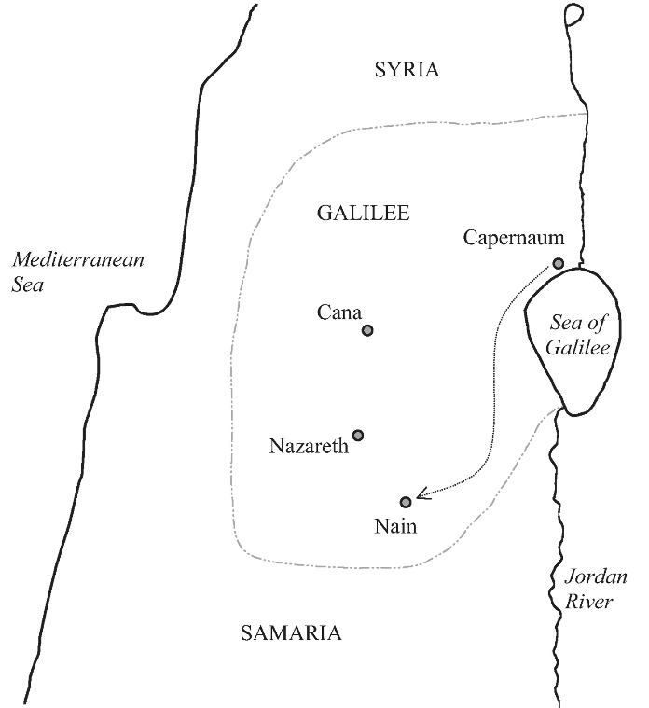

All quotations taken from the New American Standard unless otherwise noted. NASB. Nashville, TN: Thomas Nelson Publishers 1995. A free PDF of this note sheet is available: www.cssbchurch.org/sermons-2. © 2022.

