QUESTIONS FOR ADDITIONAL STUDY

1. Tell your story. Describe a time when you obeyed what you knew
God wanted you to do even though it didn’t make sense to you.

2. Why are there certain areas in our lives where we find obedience to
God to be more difficult than others?

3. Read the following passages and note what the Bible says about
obedience:

a) Exodus 19:5
b) Joshua 1:8
c) I Samuel 15:22
d) Luke 11:28
e) John 14:15
f) Romans 6:16
g) James 1:22

4. Why would it have been more difficult after the miracle to follow
Jesus than before the miracle?

5. What practical application are you going to make from this week’s
message? (Share your decision with another person.)
- I am going to ask another believer whom I trust to examine my life and tell me if there are areas where I am trusting myself and not God.
- I am going to do a Scripture study on submission to God.
- I am going to memorize Joshua 1:8.
Cornerstone Church March 12, 2023
Luke 5:1-11 Study Series #017

Five Reasons to Submit to the Lord

I. Introduction

A. Submission

B. The Setting

(See Luke 5:1; Luke 4:38-44; Numbers 34:11; Joshua 13:27;
Joshua 12:3; John 6:1; John 21:1)

The Sea of Galilee
- The largest freshwater lake in Israel (64 sq. miles or almost as large as Washington, D.C.)
- It is approximately 8 miles wide and 13 miles long.
- At 695’ below sea level, it is the lowest freshwater lake in the world, and 2nd lowest lake in the world (the 1st being the Dead Sea whose source is the Sea of Galilee!)
- It has a depth up to 151’ deep.
- Other names: Ginnosar, Lake of Gennesar, Sea of Chinneroth, Sea of Tiberias (Roman), Waters of Gennesareth.

II. Walking in Obedience to Jesus

A. Jesus is Truth

(See Luke 5:2-3; John 17:17; John 14:6; John 1:14;
Revelation 15:3)

B. Jesus is Omniscient

(See Luke 5:4-5; John 1:3; Colossians 1:16; Hebrew 1:2;
Hebrews 4:13; Matthew 10:29; Matthew 16:21-22;
Mark 8:31-32; John 21:17)
C. Jesus is Omnipotent

(See Luke 5:6-7; Nehemiah 9:6-7; Palms 104:24-30;
Daniel 4:35; Palms 62:11; Genesis 18:14; Jeremiah 32:17)

D. Jesus is Holy

(See Luke 5:8-10; Deuteronomy 6:13; Matthew 17:1;
Mark 5:37; Mark 13:3; Mark 14:33; Luke 8:51; Luke 9:28;
Job 42:5-6; Exodus 20:18-19; Isaiah 6:5)

E. Jesus is Merciful

(See Luke 5:10; Psalm 51:17; Isaiah 57:15; Isaiah 6:5-9;
Romans 5:8)

III. Conclusion

(See Luke 5:11)

IV. Communion

Communion at Cornerstone Church is open for all who profess Jesus Christ as their Lord and Savior. You do not have to be a member of Cornerstone or a member of a Southern Baptist Church to observe Communion with us. If you are a believer in Jesus Christ, you are welcome to take Communion. If you are not a believer in Jesus Christ, Scripture commands that you refrain taking Communion. (I Cor 11:26-31)

If you would like to know more about what it means to be a Christian, or if you would like to talk with someone or have someone pray for you, please see the pastor after the service and he or one of our church leaders will be glad to speak with you.

All quotations taken from the New American Standard unless otherwise noted. NASB. Nashville, TN: Thomas Nelson Publishers 1995. A free PDF of this note sheet is available: www.cssbchurch.org/sermons-2. © 2022.
Passage of Study
Luke 5:1-11

¹ Now it happened that while the crowd was pressing around Him and listening to the word of God, He was standing by the lake of Gennesaret; ² and He saw two boats lying at the edge of the lake; but the fishermen had gotten out of them and were washing their nets. ³ And He got into one of the boats, which was Simon’s, and asked him to put out a little way from the land. And He sat down and began teaching the people from the boat. ⁴ When He had finished speaking, He said to Simon, “Put out into the deep water and let down your nets for a catch.” ⁵ Simon answered and said, “Master, we worked hard all night and caught nothing, but I will do as You say and let down the nets.” ⁶ When they had done this, they enclosed a great quantity of fish, and their nets began to break; ⁷ so they signaled to their partners in the other boat for them to come and help them. And they came and filled both of the boats, so that they began to sink. ⁸ But when Simon Peter saw that, he fell down at Jesus’ feet, saying, “Go away from me Lord, for I am a sinful man!” ⁹ For amazement had seized him and all his companions because of the catch of fish which they had taken; ¹⁰ and so also were James and John, sons of Zebedee, who were partners with Simon. And Jesus said to Simon, “Do not fear, from now on you will be catching men.” ¹¹ When they had brought their boats to land, they left everything and followed Him.

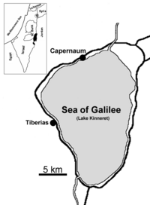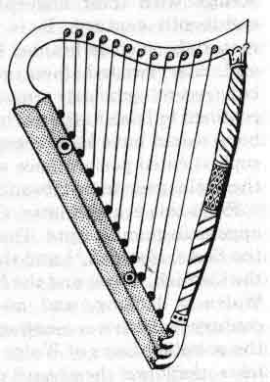
Sea of Kinneret כנרות “Kinnerot,”

