QUESTIONS FOR ADDITIONAL STUDY

1. Tell your story. Describe a time when you made a mistake about
someone’s identity, or someone mistook you for someone else.
How did the issue get corrected?

2. What are some of the different views you have heard from others
about Jesus?

3. Read the following passages and note what the Bible says about
the different opinions people had about the identity of Jesus:

a) Matthew 14:1-2
b) Matthew 21:10-11
c) Mark 8:27-28
d) Luke 9:20
e) Luke 23:3
f) John 7:12
g) John 10:33

4. Who were the Magi mentioned in the Gospel of Matthew?

5. What practical application are you going to make from this week’s
message? (Share your decision with another person.)
- I am going to read, “The Case for Christ” by Lee Strobel.
- I am going to establish a Bible reading plan for the upcoming year and read through the New Testament or the entire Bible.
- I am going to memorize Luke 9:20.
Cornerstone Church December 25, 2022
Isaiah 9:6 Special Message
Who is this Child in the Manger?

I. Introduction

A. Christmas Humor

B. Mistaken Identity

C. “A Child will be born to us, a Son will be given to us”

(See Isaiah 9:6; Galatians 4:4; John 3:16; Genesis 1:26;
Colossians 1:16; John 8:58-59; Revelation 1:8)

“A mystery which we must not attempt to fathom, for it is
utterly beyond the grasp of any finite being. As well might a gnat seek to drink in the ocean, as a finite creature to comprehend the Eternal God. A God whom we could understand would be no God. If we could grasp Him, He could not be infinite: if we could understand Him, then were He not divine.”
Charles Spurgeon

II. Who is this Child in the Manger?

A. Joseph and Mary: A Child to be Treasured

(See Luke 1:26-38; Matthew 1:18-25; Luke 1:39-45;
Matthew 1:20-21; Luke 2:16-19; Luke 2:25-33;
Luke 2:36-38; Luke 2:42-51; Revelation 2:4-5)

B. The Wise Men: A King to be Worshipped

(See Daniel 4:9; Daniel 5:11; Daniel 6:16-24; Numbers 24:17;
II Samuel 8:2; Genesis 49:10; Matthew 2:2; I Timothy 6:15;
Revelation 7:14; Revelation 19:16)

C. The Chief Priests and Scribes: A Subject to be Studied

(See Micah 5:2; Genesis 49:10; John 1:1-16; John 5:39-40)

D. Herod: A Threat to be Destroyed

(See Matthew 2:3; Genesis 25:21-34; Matthew 2:7-12;
Matthew 2:16-18; Luke 20:17-18)

E. The Shepherds: A Savior to be Praised

(Luke 2:8-20; Luke 1:47; John 4:42)

III. Conclusion

If you would like to know more about what it means to be a Christian, or if you would like to talk with someone or have someone pray for you, please contact the church office and the pastor will contact you.
Passage of Study
Isaiah 9:6

⁶ For a child will be born to us, a son will be given to us; And the government will rest on His shoulders; And His name will be called Wonderful Counselor, Mighty God, Eternal Father, Prince of Peace.

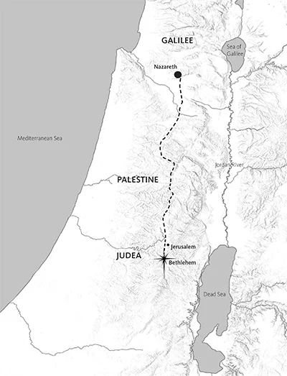
All quotations taken from the New American Standard unless otherwise noted. NASB. Nashville, TN: Thomas Nelson Publishers 1995. A free PDF of this note sheet is available: www.cssbchurch.org/sermons-2. © 2022.

