QUESTIONS FOR ADDITIONAL STUDY

1. Tell your story. Describe a time when you “cleansed” your life of a
certain habit or sin, for the purpose of pleasing God. What was
most helpful in overcoming that area in your life?

2. Why is taking care of our physical bodies also beneficial to our
spiritual life?

3. Read the following passages and note what the Bible says about
taking care of our body:

a) John 14:23
b) Romans 12:1
c) I Corinthians 3:16-17
d) I Corinthians 6:19-20
e) I Corinthians 10:31
f) II Corinthians 6:16
g) I Peter 3:4

4. What did Nehemiah do in the temple after he corrected the
problem? What spiritual application can we make to our own life?

5. What practical application are you going to make from this week’s
message? (Share your decision with another person.)
- I am going to make one change (diet, exercise, sleep, etc.) to take better care of my body as the temple of the Holy Spirit.
- I am going to going to find at least one way to make personal application o my Bible reading to my life this week.
- I am going to memorize I Corinthians 10:31.
Cornerstone Church May 22, 2022
Nehemiah 13:1-9 Study Series #24

Cleansing the Temple

I. Introduction

A. The Danger of Negligence

B. The Broken Covenant

(See Nehemiah 10:30; Ezra 6:21; Nehemiah 10:21;
Nehemiah 10:31; Exodus 20:8-11; Deuteronomy 5:12-15;
Nehemiah 10:32-39; Exodus 30:11-16; Nehemiah 13:10-29;
Nehemiah 13:6; Hebrews 2:1-3)

II. Cleansing the Temple

A. The Reading of the Law

(See Nehemiah 13:1; Nehemiah 9:3; Luke 18:10-14;
Romans 8:1)

B. The Discovery in the Law

(See Nehemiah 13:1-2; Deuteronomy 23:3-4; Genesis 19:25;
Genesis 19:30-38; Numbers 22:1-24:25; Genesis 12:3)

C. The Response to the Law

(See Nehemiah 13:3; Exodus 12:38; I Corinthians 15:33)
D. The Violation of the Law

(See Nehemiah 13:4-5; Nehemiah 2:19; Nehemiah 6:12;
Nehemiah 6:19; Nehemiah 3:1; Nehemiah 13:28;
Nehemiah 2:10; Nehemiah 2:19; Nehemiah 4:7;
Nehemiah 6:1; Nehemiah 13:6-7)

E. The Application of the Law

(See Nehemiah 13:8; Matthew 21:12-17; Mark 11:15-19;
Luke 19:45-48; John 2:13-16; Matthew 18:8-9; Judges 16:20;
Nehemiah 13:9; Matthew 12:43-45; Ephesians 4:22-29)

III. Conclusion

A. Cleansing and the Grace of God

(See Proverbs 28:13; Ruth 1:16; Ruth 4:17)

B. Cleansing Our Temple

If you would like to know more about what it means to be a Christian, or if you would like to talk with someone or have someone pray for you, please contact the church office and the pastor will contact you.
Passage of Study
Nehemiah 13:1-9

¹ On that day they read aloud from the book of Moses in the hearing of the people; and there was found written in it that no Ammonite or Moabite should ever enter the assembly of God, ² because they did not meet the sons of Israel with bread and water but hired Balaam against them to curse them. However, our God turned the curse into a blessing. ³ So when they heard the law, they excluded all foreigners from Israel.
⁴ Now prior to this, Eliashib the priest, who was appointed over the chambers of the house of our God, being related to Tobiah, ⁵ had prepared a large room for him, where formerly they put the grain offerings, the frankincense, the utensils and the tithes of grain, wine and oil prescribed for the Levites, the singers and the gatekeepers, and the contributions for the priests. ⁶ But during all this time I was not in Jerusalem, for in the thirty-second year of Artaxerxes king of Babylon I had gone to the king. After some time, however, I asked leave from the king, ⁷ and I came to Jerusalem and learned about the evil that Eliashib had done for Tobiah, by preparing a room for him in the courts of the house of God. ⁸ It was very displeasing to me, so I threw all of Tobiah’s household goods out of the room. ⁹ Then I gave an order, and they cleansed the rooms; and I returned there the utensils of the house of God with the grain offerings and the frankincense.
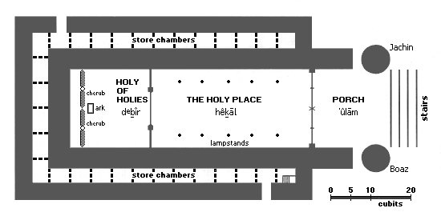

All quotations are taken from the New American Standard unless otherwise noted. NASB. Nashville, TN: Thomas Nelson Publishers 1985. A free PDF of this note sheet is available at: www.cssbchurch.org/sermons-2. © 2022.

