QUESTIONS FOR ADDITIONAL STUDY

1. Tell your story. Describe a time when you dedicated your time and
energy to a specific project. What did you have to sacrifice to do it?

2. What types of things distract us from fully dedicating our life to the
Lord?

3. Read the following passages and note what the Bible says about
dedication:

a) I Kings 8:61
b) Proverbs 14:23
c) Proverbs 16:3
d) Ecclesiastes 9:10
e) Romans 12:1-2
f) Colossians 3:17
g) Colossians 3:23-24

4. Why is thankfulness foundational in our dedication to God?

5. What practical application are you going to make from this week’s
message? (Share your decision with another person.)
- I am going to dedicate myself to God each day by setting aside a certain amount of time to read God’s Word and pray.
- I am going to going to dedicate something of mine to God to be used in ministry for His glory.
- I am going to memorize I Corinthians 10:31.
Cornerstone Church May 15, 2022
Nehemiah 12:1-47 Study Series #23

Dedicated to God

I. Introduction

A. The Dedication of Marla Runyan

(See Philippians 3:13-14; Hebrews 12:1-2)

B. The Dedication of the Jerusalem Wall

(See Nehemiah 12:27-28; Nehemiah 8:1-10:39;
Jeremiah 29:12-13)

C. The Dedication of the Priest and the Levites

(See Nehemiah 12:1-26)

II. Dedicated to God

A. The Foundation for Dedication: Thankfulness

(See Nehemiah 12:27; Nehemiah 12:8,24,27,46)

B. The Heart of Dedication: Purity

(See Nehemiah 12:30; Exodus 29:1-9; Exodus 19:10;
Leviticus 15:5; Ezekiel 36:25; Leviticus 15:27; Matthew 5:8;
I Timothy 1:5; II Timothy 2:22; I John 3:3)

C. The Requirement of Dedication: Commitment

(See Nehemiah 12:31-42; Nehemiah 2:19; Nehemiah 4:3)

D. The Expression of Dedication: Joy

(See Nehemiah 12:43-44; Nehemiah 12:27; Galatians 5:22;
Proverbs 17:22; John 15:11)

E. An Example of Dedication: David

(See Nehemiah 12:24,36,37,45,46; I Chronicles 28:11-19;
I Chronicles 24:7-19; Nehemiah 12:26; Nehemiah 12:36;
II Chronicles 29:26-27; II Samuel 5:6-10; Acts 13:36)

III. Conclusion

If you would like to know more about what it means to be a Christian, or if you would like to talk with someone or have someone pray for you, please contact the church office and the pastor will contact you.
Passage of Study
Nehemiah 12:1-47

²⁷ Now at the dedication of the wall of Jerusalem they sought out the Levites from all their places, to bring them to Jerusalem so that they might celebrate the dedication with gladness, with hymns of thanksgiving and with songs to the accompaniment of cymbals, harps and lyres. ²⁸ So the sons of the singers were assembled from the district around Jerusalem, and from the villages…

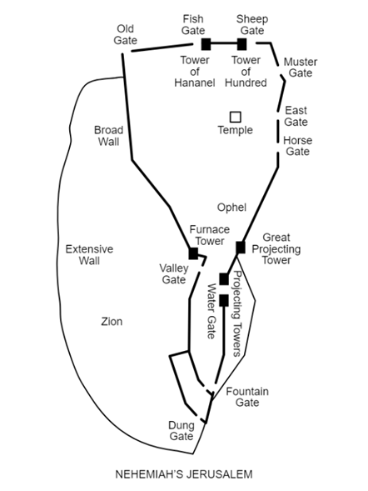

All quotations are taken from the New American Standard unless otherwise noted. NASB. Nashville, TN: Thomas Nelson Publishers 1985. A free PDF of this note sheet is available at: www.cssbchurch.org/sermons-2. © 2022.

