QUESTIONS FOR ADDITIONAL STUDY

1. Tell your story. Describe a time when you inspired by the words of
another person. What was it about their words that inspired you?

2. Who has been the most “inspiring” person in your life? (It may be a
family member, friend, pastor, or famous person.)

3. Read the following passages and note the inspiring message of these
Bible characters:
a) Genesis 50:20
b) Exodus 14:13-14
c) I Samuel 12:14-16
d) II Chronicles 20:17
e) Esther 4:13-14
f) Daniel 3:16-18
g) Acts 4:19-20

4. Why was it important for Nehemiah to share his testimony with
those who were going to participate in rebuilding the wall?

5. What practical application are you going to make from this week’s
message? (Share your decision with another person.)
- I am going to learn how to present the Gospel to another person in an easily understandable way. (Ex. The Romans Road)
- I am going to prepare my personal testimony so I can tell it to another person in two minutes or less.
- I am going to memorize Genesis 50:20.
Cornerstone Church December 12, 2021
Nehemiah 2:17-20 Study Series #05

Nehemiah Inspires the People

I. Introduction

A. Inspiration

B. Inspection

(See Nehemiah 2:11-15; Nehemiah 1:2-3)

II. Nehemiah Inspires the People

A. Nehemiah Presents the Plan to the People

(See Nehemiah 2:17; Ezra 4:7-21; Proverbs 25:28;
Hebrews 12:1; I Peter 1:13; Galatians 6:1-2)

B. Nehemiah Testifies to the People

(See Nehemiah 2:18; Nehemiah 2:8; Acts 9:1-19;
Acts 22:1-21; Acts 26:2-23)

C. The People Respond to Nehemiah

(See Nehemiah 2:18; Mark 12:30; Deuteronomy 6:5;
Psalm 78:18; Psalm 42:5; Proverbs 16:9; I Kings 19:8;
Exodus 36:2; Nehemiah 4:6; Nehemiah 4:17)

D. Nehemiah’s Adversaries Mock the People

(See Nehemiah 2:19; Nehemiah 2:10; Nehemiah 6:17-19;
Nehemiah 13:4-7; Proverbs 18:3; I Corinthians 1:27;
Ezra 4:13; Ezra 4:7-21; I Peter 5:8; Colossians 2:15)

E. Nehemiah Responds to His Adversaries

(See Nehemiah 2:20; Ezra 4:3; Psalm 1:3; Joshua 1:8)

III. Conclusion

If you would like to know more about what it means to be a Christian, or if you would like to talk with someone or have someone pray for you, please contact the church office and the pastor will contact you.
Passage of Study
Nehemiah 2:17-20

¹⁷ Then I said to them, “You see the bad situation we are in, that Jerusalem is desolate, and its gates burned by fire. Come, let us rebuild the wall of Jerusalem so that we will no longer be a reproach.” ¹⁸ I told them how the hand of my God had been favorable to me and also about the king’s words which he had spoken to me. Then they said, “Let us arise and build.” So, they put their hands to the good work. ¹⁹ But when Sanballat the Horonite, and Tobiah the Ammonite official, and Geshem the Arab heard it, they mocked us and despised us and said, “What is this thing you are doing? Are you rebelling against the king?” ²⁰ So I answered them and said to them, “The God of heaven will give us success; therefore, we His servants will arise and build, but you have no portion, right or memorial in Jerusalem.”

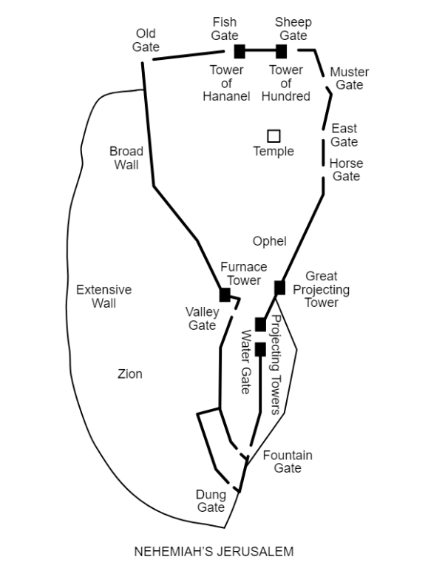

All quotations are taken from the New American Standard unless otherwise noted. NASB. Nashville, TN: Thomas Nelson Publishers 1985. A free PDF of this note sheet is available at: www.cssbchurch.org/sermons-2. © 2021.

