QUESTIONS FOR ADDITIONAL STUDY

1. Tell your story. Describe a time when you received some bad news.
How did you respond to it?

2. What “walls” in our culture do you see being broken down?

3. Read the following verses and note what the Bible says about
spiritual renewal:
a) II Chronicles 7:14
b) Psalm 51:10-12
c) Isaiah 40:31
d) Jeremiah 29:11-14
e) Romans 12:1-2
f) Ephesians 4:23
g) Revelation 2:4-5

4. What two things did Nehemiah rebuild in Jerusalem?

5. What practical application are you going to make from this week’s
message? (Share your decision with another person.)
- I am going to take a serious spiritual inventory of my life to see where there are areas of spiritual neglect.
- I am going to establish a plan to “rebuild” those spiritual areas.
- I am going to memorize Romans 12:1-2
Cornerstone Church November 14, 2021
Nehemiah 1:1-3 Study Series #01

Introduction to Nehemiah

I. Introduction

A. Lessons from an Old Fable

(See Matthew 7:24-27; Luke 6:47-49; Genesis 19:14; Job 12:4;
Psalm 31:11; Matthew 24:12; Psalm 11:3; Isaiah 28:16)

B. The History Leading Up to Nehemiah’s Work

(See Hebrews 2:3; Isaiah 30:13; Matthew 13:22)

C. Lessons from the History of Israel

(See Genesis 12:1-4; Genesis 21:5; Exodus 1:7;
Deuteronomy 1:10; I Kings 11:11-12; II Chronicles 36:17-20;
II Chronicles 36:22-23; Ezra 7:11-13; Nehemiah 1:3)

II. Nehemiah

A. Nehemiah: The Cupbearer

(See Nehemiah 1:11; Genesis 41:1-13; Daniel 1:1-7;
Revelation 19:16; Nehemiah 2:1-8)

B. Nehemiah: The Builder

(See Nehemiah 2:9-11; Nehemiah 2:12-15; Nehemiah 4:1-6;
Nehemiah 4:7-9; Nehemiah 4:10-23; Nehemiah 5:1-13;
Nehemiah 6:1-4; Nehemiah 6:5-9)

C. Nehemiah: The Governor

(See Nehemiah 5:14; Nehemiah 7:1-2; Nehemiah 8:1-3;
Nehemiah 9:32-38; Nehemiah 13:30; Matthew 5:14-16;
Jeremiah 20:9)

III. Rebuilding Our Spiritual Walls

A. Recognize Your Need

(See Psalm 26:2; Jeremiah 12:3; I Corinthians 11:28;
II Corinthians 13:5; Galatians 6:4; I Thessalonians 5:21)

B. Ask for Guidance and Protection

(See Nehemiah 1:4; Jeremiah 33:3; Luke 11:9; Mark 11:24;
Philippians 4:6)

C. Approach the Task with Determination

(See Nehemiah 2:17; Daniel 1:8)

D. Depend Upon God

(See Philippians 2:12-13; Psalm 127:1)

III. Conclusion & Communion

Communion at Cornerstone Church is open for all who profess Jesus Christ as their Lord and Savior. You do not have to be a member of Cornerstone or a member of a Southern Baptist Church to observe Communion with us. If you are a believer in Jesus Christ, you are welcome to take Communion. If you are not a believer in Jesus Christ, Scripture commands that you refrain taking Communion. (I Cor 11:26-31)

If you would like to know more about what it means to be a Christian, or if you would like to talk with someone or have someone pray for you, please contact the church office and the pastor will contact you.
Passage of Study
Nehemiah 1:1-3

¹ The words of Nehemiah the son of Hacaliah. Now it happened in the month Chislev, in the twentieth year, while I was in Susa the capitol, ² that Hanani, one of my brothers, and some men from Judah came; and I asked them concerning the Jews who had escaped and had survived the captivity, and about Jerusalem. ³ They said to me, “The remnant there in the province who survived the captivity are in great distress and reproach, and the wall of Jerusalem is broken down and its gates are burned with fire.”

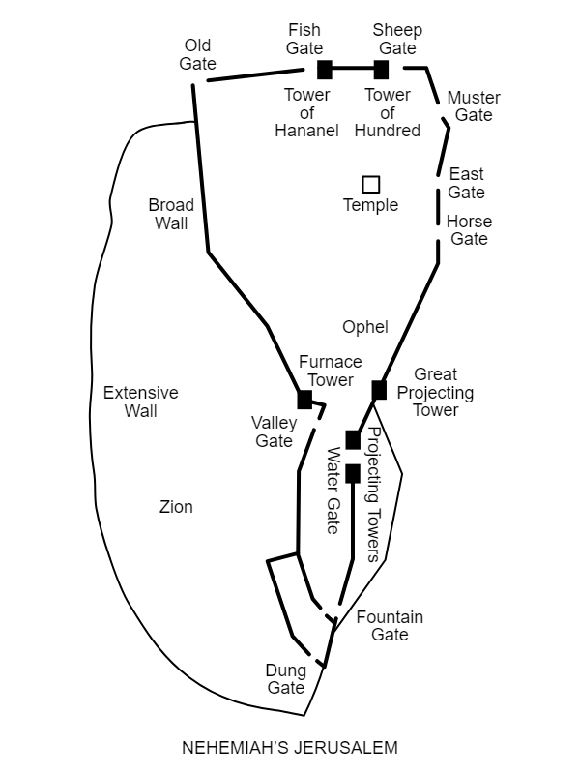

All quotations are taken from the New American Standard unless otherwise noted. NASB. Nashville, TN: Thomas Nelson Publishers 1985. A free PDF of this note sheet is available at: www.cssbchurch.org/sermons-2. © 2021.

