QUESTIONS FOR ADDITIONAL STUDY

1. Tell your story. Describe a time when you experienced a special
time of worship with the Lord. What made it special?

2. In what ways do believers demonstrate their worship of God?

3. Read the following verses and note what the Bible says about our
worship:

a) I Chronicles 16:29
b) Psalm 2:11
c) Psalm 150:1-6
d) John 4:24
e) Romans 12:1
f) Colossians 3:17
g) Hebrews 13:15

4. What had the two witnesses finished doing before they were
overcome by the beast and put to death?

5. What practical application are you going to make from this week’s
message? (Share your decision with another person.)
- I am going to commit 30 minutes to personal worship this week.
- I am going to write down all the ways I can worship God besides singing worship songs.
- I am going to memorize Colossians 3:17.
Cornerstone Church March 21, 2021
Revelation 11:15-19 Study Series # 23

The Seventh Trumpet

I. Introduction

A. The Grand View

B. The Panorama of Revelation

(See Revelation 8:13; Revelation 9:12; Joel 2:1-2;
Revelation 5:1-5; Revelation 11:14)

II. The Seventh Trumpet

A. The Announcement in Heaven

(See Revelation 11:15; Genesis 1:28; Matthew 4:8-10;
Luke 4:5-8; II Corinthians 4:4; John 12:31; Psalm 2:8;
Hebrews 2:8; Revelation 11:15; Hebrews 7:1-2; Psalm 2:9)

B. The Adoration of the Twenty-Four Elders

(See Revelation 11:16-17; Revelation 4:10-11;
Revelation 5:9-14; Matthew 28:18)

C. The Attitude of the Nations

(See Revelation 11:18; Revelation 6:15-17; Revelation 11:2;
Psalm 2:1-3)

D. The Arrival of Judgment

(See Revelation 11:18; Hebrews 9:27; Revelation 20:13;
Revelation 20:11-15; John 3:18; Romans 14:10-13;
I Corinthians 3:9-15; II Corinthians 5:9-11; Matthew 25:21;
Romans 8:18)

E. The Appearance of the Ark of the Covenant

(See Revelation 11:19; Revelation 11:1; Exodus 25:10-22;
Leviticus 16:15-17; Exodus 16:34; Numbers 17:10;
Hebrews 9:4; Revelation 4:5; Revelation 8:5)

III. Conclusion

If you would like to know more about what it means to be a Christian, or if you would like to talk with someone or have someone pray for you, please contact the church office and the pastor will contact you.
Passage of Study
Revelation 11:15-19

¹⁵ Then the seventh angel sounded; and there were loud voices in heaven, saying, “The kingdom of the world has become the kingdom of our Lord and of His Christ; and He will reign forever and ever.” ¹⁶ And the twenty-four elders, who sit on their thrones before God, fell on their faces and worshiped God, ¹⁷ saying, “We give You thanks, Lord God, the Almighty, the One who is and who was, because You have taken Your great power and have begun to reign.
¹⁸ And the nations were enraged, and Your wrath came, and the time came for the dead to be judged, and the time to reward Your bond-servants the prophets and the saints and those who fear Your name, the small and the great, and to destroy those who destroy the earth.”
¹⁹ And the temple of God which is in heaven was opened; and the ark of His covenant appeared in His temple, and there were flashes of lightning and sounds and peals of thunder, and an earthquake, and a great hailstorm.

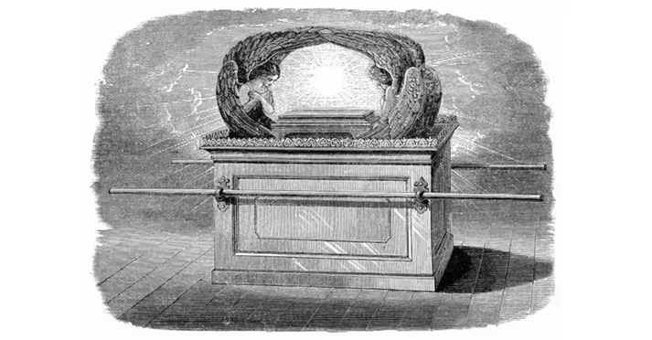

All quotations are taken from the New American Standard unless otherwise noted. NASB. Nashville, TN: Thomas Nelson Publishers 1985. A free PDF of this note sheet is available at: www.cssbchurch.org/sermons-2. © 2021.

