QUESTIONS FOR ADDITIONAL STUDY

1. Tell your story. Describe the events that brought you to the place of
salvation. What person had the greatest influence on that decision?

2. What are some positive actions Christians can take to share their
faith in practical ways with unbelievers?

3. Read the following verses and note what the Bible says about
repentance:

a) II Chronicles 7:14
b) Proverbs 28:13
c) Ezekiel 18:32
d) Acts 17:30
e) Romans 2:4
f) II Peter 3:9
g) Revelation 2:5

4. What did those who survived the sixth trumpet judgment refuse to
do?

5. What practical application are you going to make from this week’s
message? (Share your decision with another person.)
- I am going to find an unbeliever in whom I can invest time and energy to build a deeper relationship so I can share the Gospel with them.
- I am going to find a believer in whom I can invest time and energy to help them grow in their walk with Christ.
- I am going to memorize Proverbs 28:13.
Cornerstone Church February 28, 2021
Revelation 9:13-21 Study Series # 20

The Sixth Trumpet Judgment

I. Introduction

II. The Sixth Trumpet Judgment

A. The Four Angels are Released

(See Revelation 9:13-14; Exodus 30:1-10; Hebrews 9:4;
Psalm141:2; Revelation 8:3-5; Revelation 20:1; II Peter 2:4;
Jude 1:6; Deuteronomy 1:7; Joshua 1:4; Genesis 15:18;
Deuteronomy 1:7; Joshua 1:4; Genesis 2:14; Genesis 4:8;
Genesis 11:1-9; Genesis 15:18; I Chronicle 18:3;
II Chronicles 9:26; Psalm 137:1-4; Revelation 16:12-16)

B. The Four Angels Ravage the Earth

(See Revelation 9:15-16; John 2:4; Matthew 26:45;
Mark 14:41; Revelation 6:7-8)

C. The Vision of the Horses and Riders

(See Revelation 9:17; Genesis 19:24-28)

D. The Destruction of the Horses and Riders

(See Revelation 9:18-19; Genesis 7:21-23; Revelation 9:5)

E. The Refusal to Repent

(See Revelation 9:20-21; Revelation 16:9, 11, 21;
Revelation 7:1-8; Revelation 11:1-4; Revelation 14:6-7;
Acts 26:20; Galatians 6:7)

- Demon Worship (Isaiah 14:12-15; Matt 4:8-10; Luke 4:6-8)
- Idolatry (I John 5:21; I Corinthians 10:19-21)
- Murder (I John 3:15; Matthew 5:21-24 )
- Witchcraft (Galatians 5:20; Revelation 18:23)
- Sexual Immorality (Matthew 15:19; I Cor 5:1; I Thess 4:3)
- Theft (Revelation 9:21; Ephesians 4:28)

III. Conclusion

If you would like to know more about what it means to be a Christian, or if you would like to talk with someone or have someone pray for you, please contact the church office and the pastor will contact you.
Passage of Study
Revelation 9:13-21

¹³ Then the sixth angel sounded, and I heard a voice from the four horns of the golden altar which is before God, ¹⁴ saying to the sixth angel who had the trumpet, “Release the four angels who are bound at the great river Euphrates.”
¹⁵ And the four angels, who had been prepared for the hour and day and month and year, were released, so that they would kill a third of mankind. ¹⁶ The number of the armies of the horsemen was two hundred million; I heard the number of them.
¹⁷ And this is how I saw in my vision the horses and those who sat on them: the riders had breastplates the color of fire, of hyacinth, and of brimstone; and the heads of the horses are like the heads of lions; and out of their mouths came fire and smoke and brimstone.
¹⁸ A third of mankind was killed by these three plagues, by the fire, the smoke, and the brimstone which came out of their mouths. ¹⁹ For the power of the horses is in their mouths and in their tails; for their tails are like serpents and have heads, and with them they do harm.
²⁰ The rest of mankind, who were not killed by these plagues, did not repent of the works of their hands so as not to worship demons and the idols of gold, silver, brass, stone, and wood, which can neither see nor hear nor walk; ²¹ and they did not repent of their murders, nor of their witchcraft, nor of their sexual immorality, nor of their thefts.

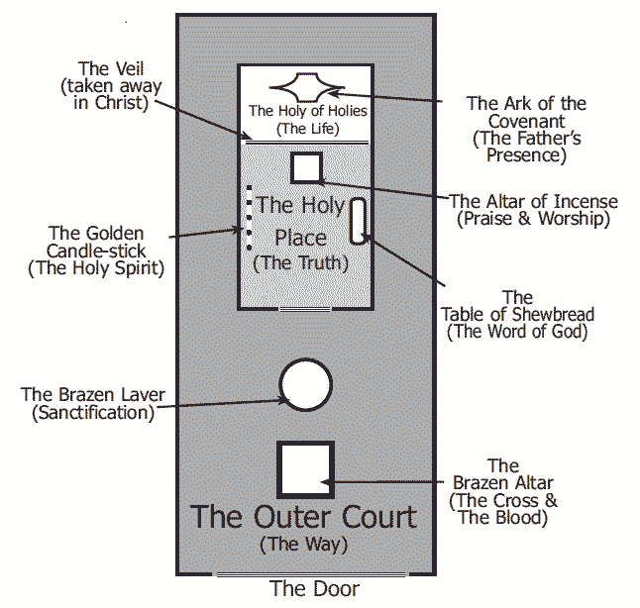
All quotations are taken from the New American Standard unless otherwise noted. NASB. Nashville, TN: Thomas Nelson Publishers 1985. A free PDF of this note sheet is available at: www.cssbchurch.org/sermons-2. © 2021.

