QUESTIONS FOR ADDITIONAL STUDY

1. Tell your story. Describe a time when you saw God definitively

answer one of your prayers.

2. The prayers of the saints were like the fragrant aroma of incense to

the Lord. What is your favorite smell? Why?

3. Read the following verses and note what the Bible says about

prayer:

a) II Chronicles 7:14

b) Psalm 34:17

c) Jeremiah 29:12-13

d) Jeremiah 33:3

e) Romans 8:26

f) I Timothy 2:1-4

g) James 5:13-18

4. What does the burning of incense represent in the temple?

5. What practical application are you going to make from this week’s

message? (*Share your decision with another person*.)

* I am going to set aside at 5 minutes each day to pray.
* I am going to read through the entire book of Revelation in the next month.
* I am going to memorize Romans 8:26.

Cornerstone Church February 2, 2021

Revelation 8:1-6 Study Series # 17

***The Seventh Seal***

**I. Introduction**

A. The Prayers of the Saints

(See Revelation 8:3-4; Colossians 4:12; Luke 18:1-8;

Isaiah 46:9-10)

B. The Present Situation

(See Revelation 1:9; John 16:33)

**II.** **The Seventh Seal**

A. Silence in Heaven

(See Revelation 8:1; Revelation 7:9-12; Revelation 4:8-11;

Mark 9:5-6; Zephaniah 1:7; Zephaniah 2:13; Habakkuk 2:20)

B. Seven Trumpets of Angels

(See Revelations 8:2; Exodus 19:16-19; I Kings 1:34-40;

Joshua 6:13-16; Revelation 1:10; Revelation 4:1;

Revelation 1:5-6; Revelation 4:9-10; Revelation 5:13;

Psalm 2:1-5; Revelation 6:12-17; Revelation 8:6 - 9:21)

The use of trumpets in ancient Israel

1) To summon an assembly of the people (Numbers 10:1-8)

2) To declare war (Numbers 10:9)

3) To announce a special event (Numbers 10:10)

C. The Prayers of the Saints

(See Revelation 8:3-4; Exodus 30:1-10; Hebrews 9:4;

Luke 1:5; Psalm 141:2; Matthew 6:10; Revelation 6:9-11;

Leviticus 16:11-14)

“Prayer does not fit us for the greater work; prayer is the

greater work.”

*Oswald Chambers, My Utmost for His Highest, Oct 17*

D. The Divine Firestorm

(See Revelation 8:5-6; Ezekiel 10:1-8; Isaiah 6:6;

Exodus 19:16-19)

**III. Conclusion**

**IV. Communion**

Communion at Cornerstone Church is open for all who profess Jesus Christ as their Lord and Savior. You do not have to be a member of Cornerstone or a member of a Southern Baptist Church to observe Communion with us. If you are a believer in Jesus Christ, you are welcome to take Communion. If you are not a believer in Jesus Christ, Scripture commands that you refrain taking Communion. (I Cor 11:26-31)

If you would like to know more about what it means to be a Christian, or if you would like to talk with someone or have someone pray for you, please contact the church office and the pastor will contact you.

**Passage of Study**

Revelation 8:1-6

**1**When *the Lamb* broke the seventh seal, there was silence in heaven for about half an hour. **2**And I saw the seven angels who stand before God, and seven trumpets were given to them.

**3**Another angel came and stood at the altar, holding a golden censer; and much incense was given to him, so that he might add it to the prayers of all the saints on the golden altar which was before the throne. **4**And the smoke of the incense ascended from the angel’s hand with the prayers of the saints before God. **5**Then the angel took the censer and filled it with the fire of the altar and hurled it to the earth; and there were peals of thunder and sounds, and flashes of lightning and an earthquake. 6 And the seven angels who had the seven trumpets prepared themselves to sound them.

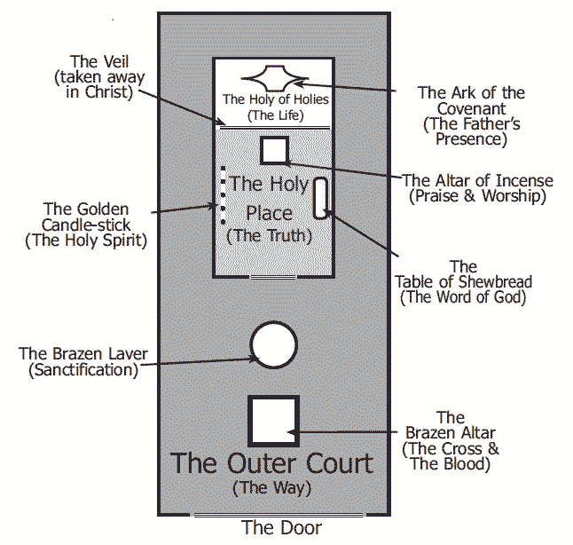

All quotations are taken from the New American Standard unless otherwise noted. NASB. Nashville, TN: Thomas Nelson Publishers 1985. A free PDF of this note sheet is available at: [www.cssbchurch.org/sermons-2](http://www.cssbchurch.org/sermons-2). © 2021.