QUESTIONS FOR ADDITIONAL STUDY

1. Tell your story. Describe a time when you felt the prompting of the
Holy Spirit to share your faith with another person. How did they
respond?

2. What are some reasons believers are hesitant to share their faith?

3. Read the following verses and note what the Bible says about
sharing our faith:

a) Romans 12:10
b) I Thessalonians 4:9
c) Hebrews 13:1
d) I Peter 1:22
e) II Peter 1:5-7
f) I John 3:10
g) I John 4:20-21

4. In what ways can you practically obey the command of Jesus to
“hold firmly to what you have so that no one will take your crown?”

5. What practical application are you going to make from this week’s
message? (Share your decision with another person.)
- I am going to write down one way I can practically apply this message to my spiritual life.
- I am going to demonstrate my love for another believer through an act of kindness.
- I am going to memorize I Peter 1:22.
Cornerstone Church November 22, 2020
Revelation 3:7-13 Study Series # 09

The Church in Philadelphia

I. Introduction

A. Modern Missions

(See Isaiah 54:2-3)

B. The City of Philadelphia

(Revelation 3:7)

C. The Church of Philadelphia

(See Revelation 3:7; Acts 19:10)

II. The Church in Philadelphia

A. Who Jesus is to the Church in Philadelphia

(See Revelation 3:7; John 10:30; Philippians 4:3;
Colossians 2:2; I Corinthians 8:5-6; Isaiah 22:15-25;
Revelation 1:18; Acts 14:27; I Corinthians 16:9;
II Corinthians 2:12; Colossians 4:3)

B. What Jesus Knows About the Church in Philadelphia

(See Revelation 3:8; Revelation 3:8; Revelation 2:2;
Revelation 2:19; Revelation 3:1; Luke 12:32;
I Corinthians 1:26; II Corinthians 12:10; Job 23:12; Acts 2:42; Revelation 3:10; I Peter 2:20)

C. What Jesus Will Do for the Church in Philadelphia

(See Revelation 3:9-11; Ephesians 6:12; Romans 2:17-29;
Daniel 9:25-27; Jeremiah 30:7; John 16:33;
I Thessalonians 4:13-5:11)

D. The Exhortation of Jesus to the Church in Philadelphia

(See Revelation 3:11; Revelation 3:10; Matthew 10:22;
Matthew 24:13; Colossians 1:22-23; I John 2:19;
Revelation 2:10; James 1:12)

E. The Promise of Jesus to the Church in Philadelphia

(See Revelation 3:12; Galatians 2:9; Revelation 2:17)

III. Conclusion

If you would like to know more about what it means to be a Christian, or if you would like to talk with someone or have someone pray for you, please contact the church office and the pastor will contact you.
Passage of Study
Revelation 3:7-13

⁷ “And to the angel of the church in Philadelphia write: He who is holy, who is true, who has the key of David, who opens and no one will shut, and who shuts and no one opens, says this: ⁸ ‘I know your deeds. Behold, I have put before you an open door which no one can shut, because you have a little power, and have followed My word, and have not denied My name. ⁹ Behold, I will make those of the synagogue of Satan, who say that they are Jews and are not, but lie—I will make them come and bow down before your feet, and make them know that I have loved you. ¹⁰ Because you have kept My word of perseverance, I also will keep you from the hour of the testing, that hour which is about to come upon the whole world, to test those who live on the earth. ¹¹ I am coming quickly; hold firmly to what you have, so that no one will take your crown. ¹² The one who overcomes, I will make him a pillar in the temple of My God, and he will not go out from it anymore; and I will write on him the name of My God, and the name of the city of My God, the new Jerusalem, which comes down out of heaven from My God, and My new name. ¹³ The one who has an ear, let him hear what the Spirit says to the churches.’
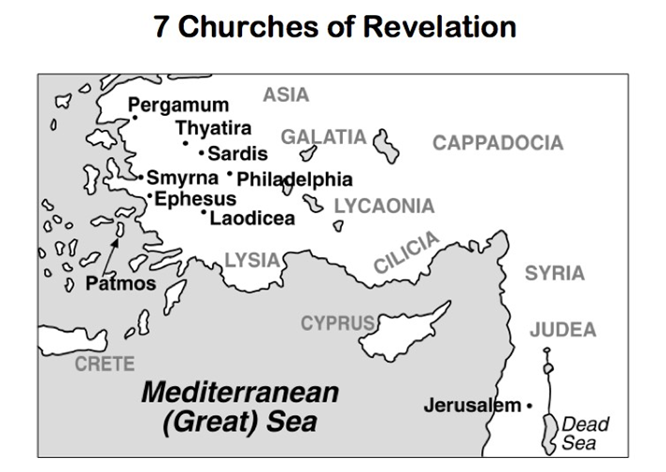
All quotations are taken from the New American Standard unless otherwise noted. NASB. Nashville, TN: Thomas Nelson Publishers 1985. A free PDF of this note sheet is available at: www.cssbchurch.org/sermons-2. © 2020.

