QUESTIONS FOR ADDITIONAL STUDY

1. Tell your story. Describe a time when you became complacent
about your spiritual life. What was the result? What did you do to
overcome your complacency?

2. What things cause Christians to become complacent in their faith?

3. Read the following verses and note what the Bible says about
complacency:

a) Proverbs 1:32
b) Proverbs 10:4
c) Proverbs 13:4
d) II Kings 19:28
e) Luke 12:19-20
f) Hebrews 5:11-12
g) Revelation 3:16

4. What does Jesus prescribe for a church (or a person) that has
become complacent?

5. What practical application are you going to make from this week’s
message? (Share your decision with another person.)
- I am going to step out of my comfort zone to find a place to serve in ministry.
- I am going to do something good that I have been putting off for a long time.
- I am going to memorize Proverbs 13:4
Cornerstone Church November 15, 2020
Revelation 3:1-6 Study Series # 08

The Church in Sardis

I. Introduction

A. The Story of Jim Sulkers

(See Revelation 3:1)

B. The City of Sardis

C. The Church of Sardis

(See Acts 19:10)

II. The Church in Sardis

A. Who Jesus is to the Church in Sardis

(See Revelation 3:1; Revelation 1:4; Ephesians 4:4;
Revelation 4:5; Revelation 5:6; Isaiah 11:2; Luke 4:18;
Acts 6:3; Exodus 31:3; Acts 9:31; Revelation 1:20)

B. What Jesus Knows About the Church in Sardis

(See Revelation 3:1; (Isaiah 42:8; Isaiah 48:11)

C. What Jesus Has Against of the Church in Sardis

(See Revelation 3:1)

D. The Exhortation of Jesus to the Church in Sardis

(See Revelation 3:2-4; Isaiah 42:3; II Peter 3:15-16;
I Timothy 6:20; Matthew 24:43; Luke 12:39;
I Thessalonians 5:2,4; II Peter 3:10; Revelation 16:15;
Revelation 2:24; Job 29:14; Isaiah 61:10; Zechariah 3:1-5;
James 1:27; Revelation 19:7-9)

E. The Promise of Jesus to the Church in Sardis

(See Revelation 3:5-6; Exodus 32:32-33; Psalm 69:28;
Revelation 1:8; Mt 25:34; Ephesians 1:4; Philippians 4:2;
Revelation 17:8; Revelation 20:12, 15; Revelation 21:27;
Matthew 10:32; Revelation 3:6)

III. Conclusion

If you would like to know more about what it means to be a Christian, or if you would like to talk with someone or have someone pray for you, please contact the church office and the pastor will contact you.
Passage of Study
Revelation 3:1-6

¹ “To the angel of the church in Sardis write: He who has the seven spirits of God and the seven stars, says this: ‘I know your deeds, that you have a name that you are alive, and yet you are dead. ² Be constantly alert, and strengthen the things that remain, which were about to die; for I have not found your deeds completed in the sight of My God. ³ So remember what you have received and heard; and keep it, and repent. Then if you are not alert, I will come like a thief, and you will not know at what hour I will come to you. ⁴ But you have a few people in Sardis who have not soiled their garments; and they will walk with Me in white, for they are worthy. ⁵ The one who overcomes will be clothed the same way, in white garments; and I will not erase his name from the book of life, and I will confess his name before My Father and before His angels. ⁶ The one who has an ear, let him hear what the Spirit says to the churches.’

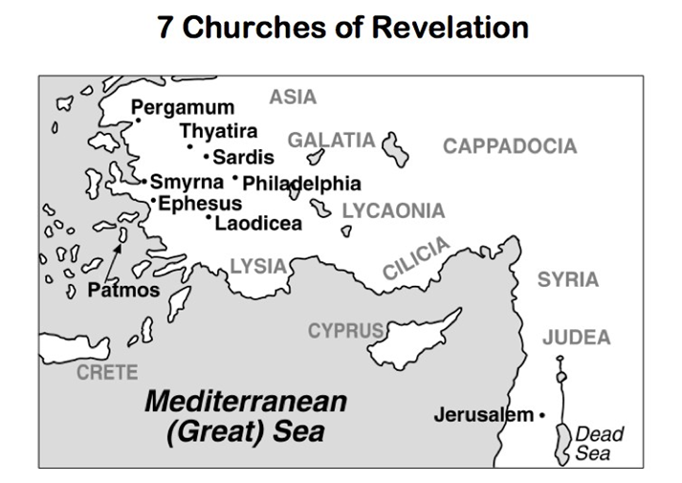

All quotations are taken from the New American Standard unless otherwise noted. NASB. Nashville, TN: Thomas Nelson Publishers 1985. A free PDF of this note sheet is available at: www.cssbchurch.org/sermons-2. © 2020.

