QUESTIONS FOR ADDITIONAL STUDY

1. Tell your story. Describe a time when you tolerated something in
your life, or in the life of someone close to you that was spiritually
harmful. What effect did that toleration have on you?

2. What things do churches “tolerate” today that would meet with the
disapproval of Jesus?

3. Read the following verses and note what the Bible says about
tolerance:

a) Matthew 7:13-14
b) I Corinthians 5:11
c) Galatians 6:1
d) II Thessalonians 3:14-15
e) II Timothy 4:1-2
f) James 4:17
g) II John 1:10-11

4. To whom was Jesus sending a message when He dealt so severely
with those in the church of Thyatira who had tolerated sin? (v. 23)

5. What practical application are you going to make from this week’s
message? (Share your decision with another person.)
- I am going to examine my own life for areas where I tolerate personal sin or sin in the life of others.
- I am going to make a list of all seven churches and compare the commendations and corrections Jesus gives to each one.
- I am going to memorize Galatian 6:1.
Cornerstone Church November 8, 2020
Revelation 2:18-29 Study Series # 07

The Church in Thyatira

I. Introduction

A. Tolerance

B. The City of Thyatira

(See Acts 16:13-15)

C. The Church of Thyatira

(See Acts 19:10)

II. The Church in Thyatira

A. Who Jesus is to the Church in Thyatira

(See Revelation 2:18; Revelation 1:14-15; Daniel 10:6;
Matthew10:26; Mark 4:22; Luke 8:17; Luke 12:2;
I Samuel 17:5-6; I Samuel 17:38; Numbers 21:9;
John 3:14-15; Exodus 27:2; Matthew 27:31; Mark 15:20;
John 19:17)

B. What Jesus Knows About the Church in Thyatira

(See Revelation 2:19; Galatians 5:22-23; II Peter 1:8)

C. What Jesus Has Against of the Church in Thyatira

(See Revelation 2:20-24; I Kings 16:29-33; Revelation 2:2-4;
Ephesians 4:15; I Corinthians 11:30; Mark 10:24;
Galatians 4:19; III John 4; Galatians 6:7; Acts 5:1-11;
I Corinthians 2:10)

D. The Exhortation of Jesus to the Church in Thyatira

(See Revelation 2:24-25; 2:19; I Thessalonians 4:13-18;
Revelation 19:11; Revelation 3:3; 16:16; 22:7; 22:17,20)

E. The Promise of Jesus to the Church in Thyatira

(See Revelation 2:26-29; Revelation 20:4; Psalm 2:8-9;
Jeremiah 19:11; Revelation 2:28; 22:16; II Peter 1:19;
Numbers 24:17; Song of Solomon 2:16; 6:3)

III. Conclusion
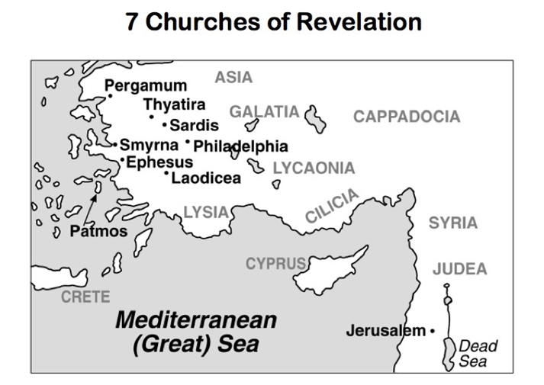

If you would like to know more about what it means to be a Christian, or if you would like to talk with someone or have someone pray for you, please contact the church office and the pastor will contact you.
Passage of Study
Revelation 2:18-29

¹⁸ “And to the angel of the church in Thyatira write:
The Son of God, who has eyes like a flame of fire, and feet like burnished bronze, says this:
¹⁹ ‘I know your deeds, and your love and faith, and service and perseverance, and that your deeds of late are greater than at first. ²⁰ But I have this against you, that you tolerate the woman Jezebel, who calls herself a prophetess, and she teaches and leads My bond-servants astray so that they commit sexual immorality and eat things sacrificed to idols. ²¹ I gave her time to repent, and she does not want to repent of her sexual immorality. ²² Behold, I will throw her on a bed of sickness, and those who commit adultery with her into great tribulation, unless they repent of her deeds. ²³ And I will kill her children with plague, and all the churches will know that I am He who searches the minds and hearts; and I will give to each one of you according to your deeds. ²⁴ But I say to you, the rest who are in Thyatira, who do not hold this teaching, who have not known the deep things of Satan, as they call them—I place no other burden on you. ²⁵ Nevertheless what you have, hold firmly until I come. ²⁶ The one who overcomes, and the one who keeps My deeds until the end, I will give him authority over the nations; ²⁷ and he shall rule them with a rod of iron, as the vessels of the potter are shattered, as I also have received authority from My Father; ²⁸ and I will give him the morning star. ²⁹ The one who has an ear, let him hear what the Spirit says to the churches.’

All quotations are taken from the New American Standard unless otherwise noted. NASB. Nashville, TN: Thomas Nelson Publishers 1985. A free PDF of this note sheet is available at: www.cssbchurch.org/sermons-2. © 2020.

