QUESTIONS FOR ADDITIONAL STUDY

1. Tell your story. Describe a time when compromised your faith
because of pressure from others. What did you feel afterwards?

2. In what areas of the church today do you see compromise?

3. Read the following verses and note what the Bible says about
compromise:

a) Joshua 24:14-15
b) I Kings 18:21
c) Psalm 119:10
d) Romans 12:1-2
e) Matthew 6:24
f) Luke 9:62
g) James 4:17

4. How was the repentance of the church in Pergamum two-fold?

5. What practical application are you going to make from this week’s
message? (Share your decision with another person.)
- I am going to ask a close friend if they see any compromise in my life.
- I am going to read ahead for next week’s message. (Rev 2:18-29)
- I am going to memorize Romans 12:1-2.
Cornerstone Church November 1, 2020
Revelation 2:12-17 Study Series # 06

The Church in Pergamum

I. Introduction

A. Compromise

B. The Name Pergamum

(Matthew 3:7-9)

C. The City of Pergamum

(See Numbers 21:4-9; John 3:14-15)
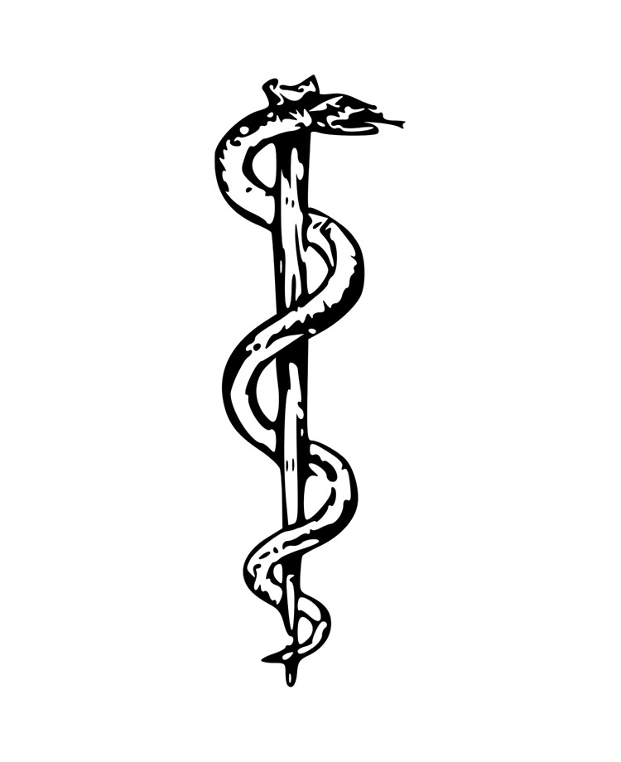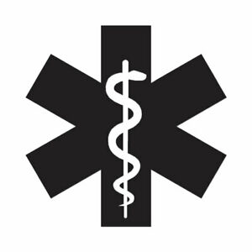
The Emblem of Asclepius Modern Medical Symbol

D. The Church of Pergamum

(See Acts 16:7-8; Acts 19:10)

II. The Church in Pergamum

A. Who Jesus is to the Church in Pergamum

(See Revelation 2:12; Romans 13:3-4; Isaiah 49:2-3;
John 5:22-23; Revelation 1:16; Revelation 2:16;
Revelation 19:15; Hebrews 4:12; John 1:14)
B. What Jesus Knows About the Church in Pergamum

(See Revelation 2:13; Daniel 10:13; Daniel 10:20; Mark 13:31;
Revelation 1:5; Revelation 3:14)

C. What Jesus Has Against of the Church in Pergamum

(See Revelation 2:14-15; Numbers 22:1-25:18; Revelation 2:6)

D. The Exhortation of Jesus to the Church in Pergamum

(See Revelation 2:16-17; Hebrews 4:12; Matthew 18:15-17;
Revelation 2:7; Revelation 2:11; Revelation 2:17)

E. The Promise of Jesus to the Church in Pergamum

(See Revelation 2:17; Exodus 16:1-36; Hebrews 9:3-4;
Revelation 2:14; Matthew 4:4; John 6:32-33; John 6:48;
Revelation 19:12; Deuteronomy 29:29; Genesis 17:5;
Genesis 32:28; Acts 13:9; Acts 4:26)

III. Conclusion

Communion at Cornerstone Church is open for all who profess Jesus Christ as their Lord and Savior. You do not have to be a member of Cornerstone or a member of a Southern Baptist Church to observe Communion with us. If you are a believer in Jesus Christ, you are welcome to take Communion. If you are not a believer in Jesus Christ, Scripture commands that you refrain taking Communion. (I Cor 11:26-31)

If you would like to know more about what it means to be a Christian, or if you would like to talk with someone or have someone pray for you, please contact the church office and the pastor will contact you.
Passage of Study
Revelation 2:12-17

¹² “And to the angel of the church in Pergamum write: The One who has the sharp two-edged sword says this: ¹³ ‘I know where you dwell, where Satan’s throne is; and you hold firmly to My name, and did not deny My faith even in the days of Antipas, My witness, My faithful one, who was killed among you, where Satan dwells. ¹⁴ But I have a few things against you, because you have some there who hold the teaching of Balaam, who kept teaching Balak to put a stumbling block before the sons of Israel, to eat things sacrificed to idols and to commit sexual immorality. ¹⁵ So you too, have some who in the same way hold to the teaching of the Nicolaitans. ¹⁶ Therefore repent; or else I am coming to you quickly, and I will wage war against them with the sword of My mouth. ¹⁷ The one who has an ear, let him hear what the Spirit says to the churches. To the one who overcomes, I will give some of the hidden manna, and I will give him a white stone, and a new name written on the stone which no one knows except the one who receives it.’
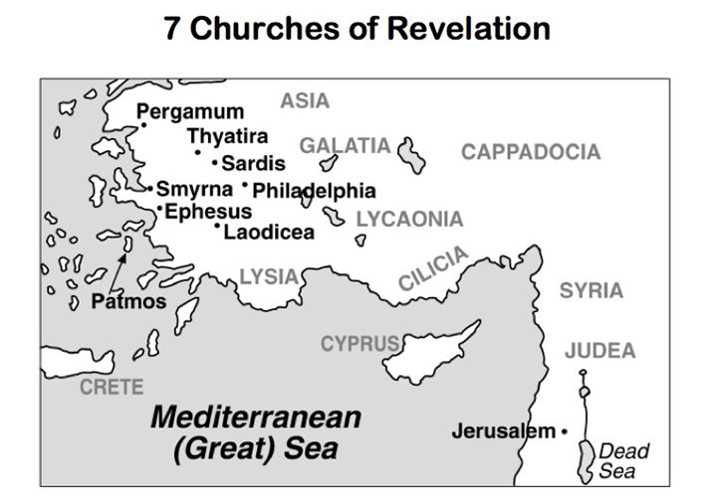

All quotations are taken from the New American Standard unless otherwise noted. NASB. Nashville, TN: Thomas Nelson Publishers 1985. A free PDF of this note sheet is available at: www.cssbchurch.org/sermons-2. © 2020.

