QUESTIONS FOR ADDITIONAL STUDY

1. Tell your story. Describe a time when you were treated poorly by
others because of your faith. How did you respond?

2. What indications of persecution toward Christians do you presently
see in the world today?

3. Read the following verses and note what the Bible says about
suffering:

a) Psalm 34:19
b) John 16:33
c) Romans 5:3-5
d) Romans 8:18
e) James 1:2-4
f) I Peter 5:10
g) Revelation 21:4

4. In what ways are Christians who may not be financially wealthy
considered rich from a biblical perspective?

5. What practical application are you going to make from this week’s
message? (Share your decision with another person.)
- I am going to read ahead each week to be prepared for the upcoming message.
- I am going to read “Foxes Book of Martyrs.”
- I am going to give a copy of “Jesus Freaks” to a young person and encourage them to read it.
- I am going to memorize Romans 8:18.
Cornerstone Church October 25, 2020
Revelation 2:8-11 Study Series # 05

The Church in Smyrna

I. Introduction

A. The Persecuted Church

B. The Name of Smyrna

(See Genesis 37:25; Exodus 30:22-28; Esther 2:12;
Songs of Songs 4:14; Matthew 2:11; Revelation 19:16;
Hebrews 4:14; Galatians 2:20; John 19:39)

C. The History of Smyrna

D. The Church Leader of Smyrna: Polycarp

II. The Church in Smyrna

A. Who Jesus is to the Church in Smyrna

(See Revelation 2:8; Isaiah 41:4; Isaiah 44:6; Isaiah 48:12;
I Peter 3:18)

B. What Jesus Knows About the Church in Smyrna

(See Revelation 2:9; II Corinthians 2:15; James 2:5;
Matthew 5:3; II Corinthians 6:10; Galatians 3:29;
John 8:31-47)

C. What Jesus Expects of the Church in Smyrna

(See Revelation 2:10; John 16:33; Matthew 10:28;
Psalm 56:11; James 1:1-2; I Corinthians 10:13;
II Corinthians 12:9; Genesis 24:55; I Samuel 25:38;
Daniel 1:12; II Corinthians 4:17-18; James 1:12)

D. The Exhortation of Jesus to the Church in Smyrna

(See Revelation 2:11; James 1:22-24; II Timothy 3:7)

E. The Promise of Jesus to the Church in Smyrna

(See Revelation 2:11; Revelation 20:11-15; Revelation 20:14;
Revelation 21:8)

III. Conclusion

(See I Corinthians 15:55-57; Hosea 13:14)

If you would like to know more about what it means to be a Christian, or if you would like to talk with someone or have someone pray for you, please contact the church office and the pastor will contact you.
Passage of Study
Revelation 2:9-11

⁸ “And to the angel of the church in Smyrna write: The first and the last, who was dead, and has come to life, says this: ⁹ ‘I know your tribulation and your poverty (but you are rich), and the blasphemy by those who say they are Jews and are not, but are a synagogue of Satan. ¹⁰ Do not fear what you are about to suffer. Behold, the devil is about to cast some of you into prison, so that you will be tested, and you will have tribulation for ten days. Be faithful until death, and I will give you the crown of life. ¹¹ He who has an ear, let him hear what the Spirit says to the churches. He who overcomes will not be hurt by the second death.’

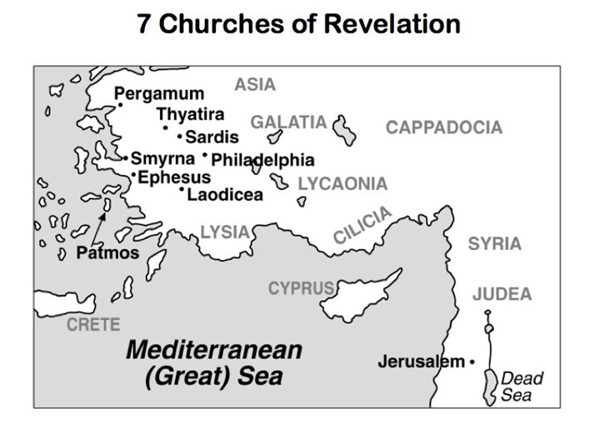

Suggested Reading:

Foxe’s Book of Martyrs by John Foxe
Jesus Freaks by D.C. Talk and Voice of the Martyrs
The Voice of the Martyrs Magazine

All quotations are taken from the New American Standard unless otherwise noted. NASB. Nashville, TN: Thomas Nelson Publishers 1985. A free PDF of this note sheet is available at: www.cssbchurch.org/sermons-2. © 2020.

