QUESTIONS FOR ADDITIONAL STUDY

1. Tell your story. Describe a time when took on a difficult task or
project and completed it. How did you feel about your
accomplishment?

2. What are some reasons believers become cold and indifferent about
their faith?

3. Read the following verses and note what the Bible says about
finishing well in our faith:

a) Ecclesiastes 7:8
b) Luke 14:28-30
c) Acts 20:24
d) I Corinthians 9:24-27
e) II Timothy 4:7
f) II John 1:8
g) Hebrews 12:1-3

4. What three things does Jesus instruct the church in Ephesus to do to
renew their relationship with Him? (See Revelation 2:5)

5. What practical application are you going to make from this week’s
message? (Share your decision with another person.)
- I am going to establish a plan for spiritual growth based on daily time set aside to read Scripture, prayer, and fellowship with other believers.
- I am going to pray for revival for our nation, our church, and my own personal life for the next 30 days.
- I am going to memorize Galatians 6:9.
Cornerstone Church October 18, 2020
Revelation 2:1-7 Study Series # 04

The Church in Ephesus

I. Introduction

A. Finishing Well

(See II Timothy 4:7; I Corinthians 9:24-27)

B. The Seven Churches

The Pattern:
The Greeting – The Commendation –
The Concern – The Command – The Counsel

C. The City of Ephesus

(See Acts 19:10; Acts 19:23-41)

II. The Church in Ephesus

A. The Address of Jesus to the Church

(See Revelation 2:1; Matthew 18:10; Revelation 2:5;
Hebrews 2:14-17; Matthew 11:10; Mark 1:2; Luke 7:27;
Revelation 1:20; I Peter 5:2-3; Revelation 2:2;
Revelation 2:19; Revelation 3:1; Revelation 3:8;
Revelation 3:15)

B. What Jesus Knows About the Church

(See Revelation 2:2-3; Acts 20:13-38)

C. What Jesus Has Against the Church

(See Revelation 2:4; Acts 19:8-10; John 19:26; John 20:2;
John 21:7; John 21:20)

D. What Jesus Wants of the Church

(See Revelation 2:5-6; Psalm 42:4; II Corinthians 7:9-10;
Revelation 2:15; Matthew 19:13-14; II Corinthians 1:24)

- Remember
- Repent
- Return

E. The Exhortation of Jesus

(See Revelation 2:7)

F. The Promise of Reward
(See Revelation 2:7; I John 5:4-5; Genesis 2:9;
Revelation 22:2; Revelation 22:14)

IV. Conclusion

If you would like to know more about what it means to be a Christian, or if you would like to talk with someone or have someone pray for you, please contact the church office and the pastor will contact you.
Passage of Study
Revelation 2:1-7

¹ “To the angel of the church in Ephesus write: The One who holds the seven stars in His right hand, the One who walks among the seven golden lampstands, says this: ² ‘I know your deeds and your toil and perseverance, and that you cannot tolerate evil men, and you put to the test those who call themselves apostles, and they are not, and you found them to be false; ³ and you have perseverance and have endured for My name’s sake, and have not grown weary. ⁴ But I have this against you, that you have left your first love. ⁵ Therefore remember from where you have fallen, and repent and do the deeds you did at first; or else I am coming to you and will remove your lampstand out of its place—unless you repent. ⁶ Yet this you do have, that you hate the deeds of the Nicolaitans, which I also hate. ⁷ He who has an ear, let him hear what the Spirit says to the churches. To him who overcomes, I will grant to eat of the tree of life which is in the Paradise of God.’

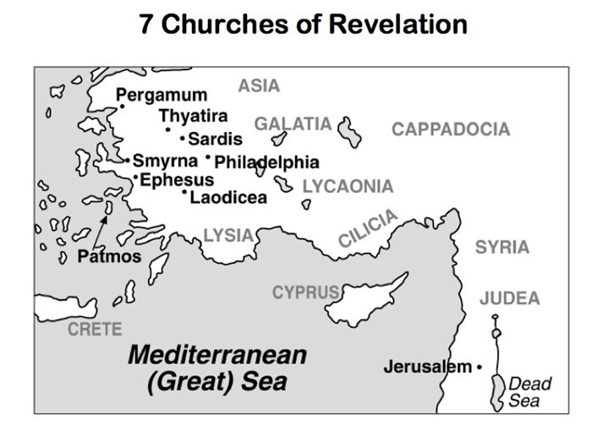

All quotations are taken from the New American Standard unless otherwise noted. NASB. Nashville, TN: Thomas Nelson Publishers 1985. A free PDF of this note sheet is available at: www.cssbchurch.org/sermons-2. © 2020.

