QUESTIONS FOR ADDITIONAL STUDY

1. Tell your story. Describe a time when you the Lord spoke to your
heart in a special way.

2. What types of things hinder our ability to hear God’s guidance in
our lives?

3. Read the following verses and note what the Bible says about
visions:

a) Genesis 40:8
b) Numbers 12:6
c) Deuteronomy 13:1-3
d) Jeremiah 23:32
e) Joel 2:28
f) Amos 3:7
g) I John 4:1

4. How does God use isolation in the life of a believer?

5. What practical application are you going to make from this week’s
message? (Share your decision with another person.)
- I am going to turn off the television for one week and devote that time to my personal spiritual growth.
- I am going to begin a spiritual journal in which I record what God is doing in my life and write in it at least once a week.
- I am going to memorize I John 4:1.
Cornerstone Church October 11, 2020
Revelation 1:9-20 Study Series # 03

The Vision of John

I. Introduction

II. The Vision of John on the Isle of Patmos

A. The Isolation of John

(See Revelation 1:9; John 13:35; Matthew 24:35; Mark 13:31;
Luke 21:33; Exodus 2:15; I Kings 19:4-18; Mark 1:1-8;
Galatians 1:15-19)

B. The Instruction to John

(See Revelation 1:10-11; Acts 20:7; I Corinthians 16:2;
Ezekiel 3:12; Exodus 19:16)

C. The Vision of Jesus to John

(See Revelation 1:12-16; Hebrews 4:14; Hebrews 4:12;
John 1:14)

D. The Response of John

(See Revelation 1:17-18; Ezekiel 1:28; Ezekiel 3:23;
Ezekiel 43:3; Luke 5:1-11; Matthew 14:27; Mark 6:50;
Matthew 17:7; Isaiah 44:6; 48:12; II Timothy 1:10;
John 11:25; John 14:19)

E. The Explanation Given to John

(See Revelation 1:19-20; Matthew 5:14; Philippians 2:15)

IV. Conclusion

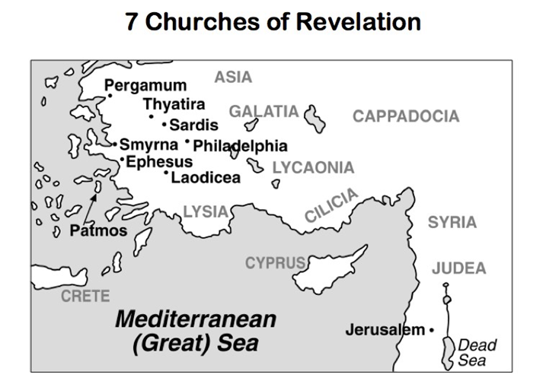

Communion at Cornerstone Church is open for all who profess Jesus Christ as their Lord and Savior. You do not have to be a member of Cornerstone or a member of a Southern Baptist Church to observe Communion with us. If you are a believer in Jesus Christ, you are welcome to take Communion. If you are not a believer in Jesus Christ, Scripture commands that you refrain taking Communion. (I Cor 11:26-31)

If you would like to know more about what it means to be a Christian, or if you would like to talk with someone or have someone pray for you, please contact the church office and the pastor will contact you.
Passage of Study
Revelation 1:9-20

⁹ I, John, your brother and fellow partaker in the tribulation and kingdom and perseverance which are in Jesus, was on the island called Patmos because of the word of God and the testimony of Jesus. ¹⁰ I was in the Spirit on the Lord’s day, and I heard behind me a loud voice like the sound of a trumpet, ¹¹ saying, “Write in a book what you see, and send it to the seven churches: to Ephesus and to Smyrna and to Pergamum and to Thyatira and to Sardis and to Philadelphia and to Laodicea.”
¹² Then I turned to see the voice that was speaking with me. And having turned I saw seven golden lampstands; ¹³ and in the middle of the lampstands I saw one like a son of man, clothed in a robe reaching to the feet, and girded across His chest with a golden sash. ¹⁴ His head and His hair were white like white wool, like snow; and His eyes were like a flame of fire. ¹⁵ His feet were like burnished bronze, when it has been made to glow in a furnace, and His voice was like the sound of many waters. ¹⁶ In His right hand He held seven stars, and out of His mouth came a sharp two-edged sword; and His face was like the sun shining in its strength.
¹⁷ When I saw Him, I fell at His feet like a dead man. And He placed His right hand on me, saying, “Do not be afraid; I am the first and the last, ¹⁸ and the living One; and I was dead, and behold, I am alive forevermore, and I have the keys of death and of Hades. ¹⁹ Therefore write the things which you have seen, and the things which are, and the things which will take place after these things. ²⁰ As for the mystery of the seven stars which you saw in My right hand, and the seven golden lampstands: the seven stars are the angels of the seven churches, and the seven lampstands are the seven churches.

All quotations are taken from the New American Standard unless otherwise noted. NASB. Nashville, TN: Thomas Nelson Publishers 1985. A free PDF of this note sheet is available at: www.cssbchurch.org/sermons-2. © 2020.

