QUESTIONS FOR ADDITIONAL STUDY

1. Tell your story. Describe a time you experienced the conviction of
the Holy Spirit and felt the need to make a change based on that
conviction.

2. What are some of the false teachings that are being circulated today
in churches?

3. Read the following verses and note what the Bible says about
prophecy:
a) Deuteronomy 18:18-22
b) Amos 3:7
c) Romans 12:6
d) I Corinthians 13:2
e) I Corinthians 14:22
f) II Peter 1:20-21
g) Revelation 19:10

4. How has God demonstrated His grace in withholding His judgment
when it was deserved. Give an example from Scripture.

5. What practical application are you going to make from this week’s
message? (Share your decision with another person.)
- I am going to ask the Lord to examine my heart to see if there are any things of which I need to repent. (Psalm 139:23-24)
- I am going to compare the characteristics of false teachers using the list by Jude (vv. 5-16) and Peter (II Peter 2:1-22)
- I am going to memorize II Peter 1:20-21.
Cornerstone Church September 6, 2020
Jude 14 – 16 Study Series # 05

The Acts of the Apostates
Part 5 – The Coming Judgment
I. Introduction

A. Religious Deception

B. Judgment of False Teachers

(See Jude 4; Galatians 6:7)

II. The Coming Judgment

A. The Messenger

(See Jude 14-15; Genesis 5:18-24; Hebrews 11:5;
Genesis 4:17; Genesis 5:22-24; Acts 17:28; Luke 13:1-5;
Genesis 5:21; Genesis 5:24; I John 3:2-3; Genesis 6:5)

B. The Method

(See Jude 14; Luke 17:26-27; Deuteronomy 33:2; Daniel 4:17;
Colossians 3:4; I Thessalonians 3:13; Revelation 19:14;
John 14:1-3; I Thessalonians 4:17-18)

C. The Scope

(See Jude 15; Genesis 7:23; Genesis 19:24-25; John 3:18;
John 5:24; Genesis 19:16; Genesis 19:22; II Peter 2:7)

D. The Message

(See Jude 15; Isaiah 30:18; John 5:22; Romans 1:20;
Romans 3:19; II Corinthians 5:10; Revelation 20:12;
I Samuel 16:7; Zechariah 2:8)

E. The Mindset

(See Jude 16)

- Grumblers (Exodus 16:7-8; Numbers 14:27-29)
- Finding Fault (Numbers 20:1-13; 21:4-9; I Cor 10:9-10)
- Lustful (II Peter 2:10; II Peter 2:18; II Peter 3:3)
- Arrogant (Luke 18:9-14; Proverbs 8:13; 27:2)
- Flattering (II Timothy 4:3-4; Prov 29:5; Romans 16:18;
Proverbs 26:24-28; Psalm 12:3)

IV. Conclusion

Communion at Cornerstone Church is open for all who profess Jesus Christ as their Lord and Savior. You do not have to be a member of Cornerstone or a member of a Southern Baptist Church to observe Communion with us. If you are a believer in Jesus Christ, you are welcome to take Communion. If you are not a believer in Jesus Christ, Scripture commands that you refrain taking Communion. (I Cor 11:26-31)

If you would like to know more about what it means to be a Christian, or if you would like to talk with someone or have someone pray for you, please contact the church office and the pastor will contact you.
Passage of Study
Jude 14 - 16

¹⁴ It was also about these men that Enoch, in the seventh generation from Adam, prophesied, saying, “Behold, the Lord came with many thousands of His holy ones, ¹⁵ to execute judgment upon all, and to convict all the ungodly of all their ungodly deeds which they have done in an ungodly way, and of all the harsh things which ungodly sinners have spoken against Him." ¹⁶ These are grumblers, finding fault, following after their own lusts; they speak arrogantly, flattering people for the sake of gaining an advantage.

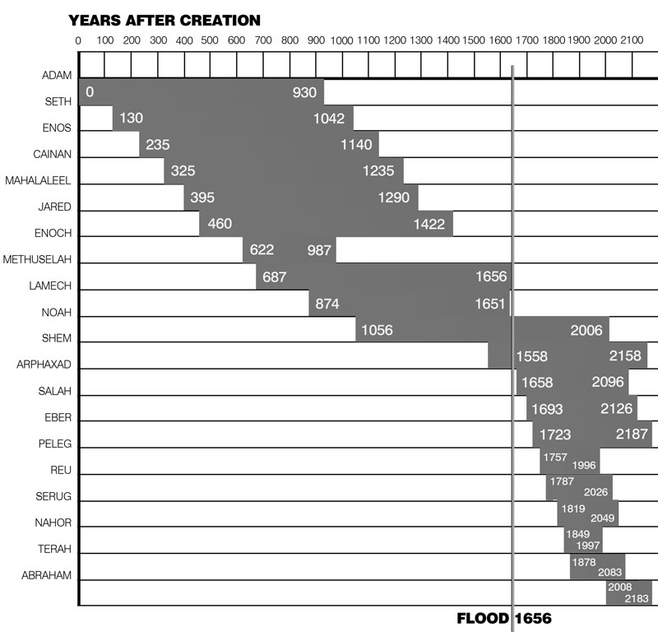

All quotations are taken from the New American Standard unless otherwise noted. NASB. Nashville, TN: Thomas Nelson Publishers 1985. A free PDF of this note sheet is available at: www.cssbchurch.org/sermons-2. © 2020.

