QUESTIONS FOR ADDITIONAL STUDY

1. Tell your story. Describe a time when you put your trust in someone
or something and was disappointed. What did you learn from the
experience?

2. Of the various ways in which John describes Jesus Christ in this
passage, which is most significant to you? Why?

3. Read the following verses and note what the Bible says about
Jesus:

a) Isaiah 9:6
b) Isaiah 53:5
c) John 1:1,14
d) Acts 4:12
e) Colossians 2:9
f) I Timothy 2:5
g) Hebrews 1:3

4. Why do you think John spent so much time in his description of
Jesus Christ in the opening verses of Revelation?

5. What practical application are you going to make from this week’s
message? (Share your decision with another person.)
- I am going to pray for our nation by praying for our President, our Congress, and our Judicial system.
- I am going to pray for our police officers, our Fire & Rescue personnel, and our military every time I see a police car.
- I am going to memorize Acts 4:12.
Cornerstone Church September 27, 2020
Revelation 1:4-8 Study Series # 02

Jesus Christ – The Only Firm Foundation

I. Introduction

A. The Firm Foundation

(Psalm 11:3; Isaiah 5:20; Psalm 62:5; Matthew 7:24-27)

B. A Second Introduction

(See Revelation 1:1-3; Revelation 1:4-6)

II. The Work of God within the Body of Christ

A. The Original Recipients

(See Revelation 1:4; Hebrews 10:24-25; John 13:35;
Romans 1:1; I Corinthians 1:3; II Corinthians 1:2;
Galatians 1:3; Ephesians 1:2; Philippians 1:2; Colossians 1:2;
I Thessalonians 1:1; II Thessalonians 1:2; I Timothy 1:2;
II Timothy 1:2; Titus 1:4; Philemon 1:3; I Peter 1:2;
II Peter 1:2; II John 1:3

“Is there any significance to the fact that John addresses
seven churches?”

B. The Origin of the Message

(See Revelation 1:4-5; Exodus 3:13-14; Isaiah 11:2;
Genesis 1:26 Revelation 3:1; Revelation 4:5; Revelation 5:6;
Zechariah 4:1-10)

“What about John’s reference to the seven Spirts who are
before God’s throne?”

C. The Description of Jesus Christ

(See Revelation 1:5; Hebrews 13:8; Colossians 1:18;
I Timothy 6:15; Revelation 17:14; Revelation 19:16;
Psalm 89:27; Proverbs 21:1; Hebrews 4:16)

D. The Message of Jesus Christ

(See Revelation 1:7; Acts 1:9-11; Zechariah 12:10;
Revelation 1:8; Revelation 21:6; Revelation 22:13)

IV. Conclusion

If you would like to know more about what it means to be a Christian, or if you would like to talk with someone or have someone pray for you, please contact the church office and the pastor will contact you.
Passage of Study
Revelation 1:4-8

⁴ John to the seven churches that are in Asia: Grace to you and peace, from Him who is and who was and who is to come, and from the seven Spirits who are before His throne, ⁵ and from Jesus Christ, the faithful witness, the firstborn of the dead, and the ruler of the kings of the earth. To Him who loves us and released us from our sins by His blood— ⁶ and He has made us to be a kingdom, priests to His God and Father—to Him be the glory and the dominion forever and ever. Amen. ⁷ Behold, He is coming with the clouds, and every eye will see Him, even those who pierced Him; and all the tribes of the earth will mourn over Him. So it is to be. Amen. ⁸ “I am the Alpha and the Omega,” says the Lord God, “who is and who was and who is to come, the Almighty.”

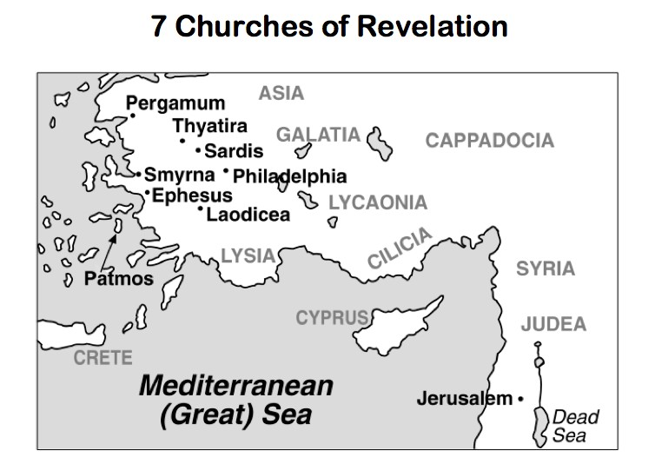

All quotations are taken from the New American Standard unless otherwise noted. NASB. Nashville, TN: Thomas Nelson Publishers 1985. A free PDF of this note sheet is available at: www.cssbchurch.org/sermons-2. © 2020.

